The Pizza Party Problem
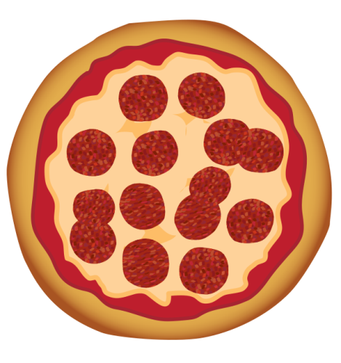

If we cut each pizza into 6 equal slices, how many total slices will we have? What kind of fractions can we make?

Possible discussion questions for student discourse:
- What if each student wants more than one slice? How could we cut the pizzas differently?

- What is the total number of pizza slices? What would that fraction look like if you have one slice out of all of them?

- If 4 students each had a slice, what fraction would represent their slices?

- If we cut up the pizza so we have 8 slices instead of 6 slices, how many total pieces will we have? What number in the fraction will change? The numerator or the denominator?

