The Pizza Party Problem
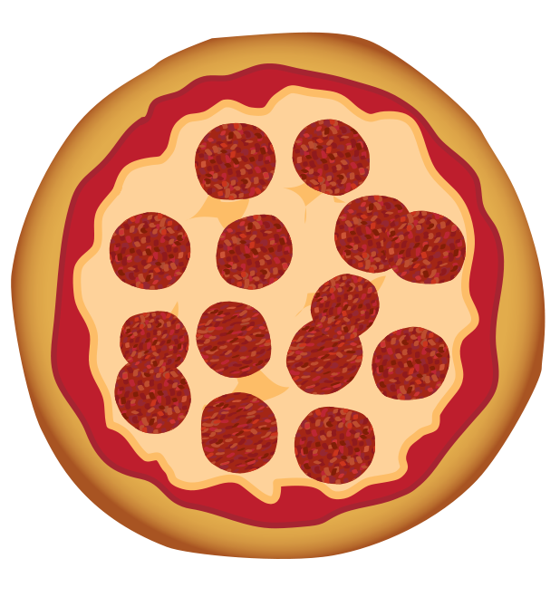

We have three pizzas for our class party! How can we cut these to make sure all 18 students the same amount of pizza?

Possible discussion questions for student discourse:
- Do we have to cut the all 3 pizzas the same for everyone to get equal slices?

- How many total slices are needed for everyone?

- What if each student wants more than one slice? How could we cut the pizzas differently?

Possible questions for part-whole relationships:
- How many slices is each whole pizza cut into?

- If you just eat 1 slice, is that part of the pizza or the whole pizza?

- If we cut up the pizza so we have 8 slices instead of 6 slices, we have more slices, but what happens to the size of each slice?

