Identifying the Part & the Whole

There are 9 pieces of fruit in the whole group.
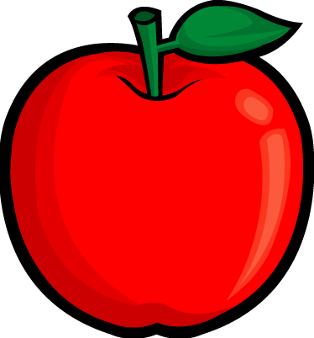
Part of the group is 3 bananas.
Part of the group is 6 apples.

Identify the Part & the Whole: Stations

Example:
What items are in your whole group?
apples and bananas
9
How many are in the whole group? ___________
apples
What is a part your whole group made up of? ___________
6
How many are in that part of your whole group? ___________

Station 1:
What items are in your whole group?

How many are in the whole group? ___________
What is a part your whole group made up of? ___________
How many are in that part of your whole group? ___________

Station 2:
What items are in your whole group?

How many are in the whole group? ___________
What is a part your whole group made up of? ___________
How many are in that part of your whole group? ___________

Station 3:
What items are in your whole group?

How many are in the whole group? ___________
What is a part your whole group made up of? ___________
How many are in that part of your whole group? ___________

Station 4:
What items are in your whole group?

How many are in the whole group? ___________
What is a part your whole group made up of? ___________
How many are in that part of your whole group? ___________

Station 5:
What items are in your whole group?

How many are in the whole group? ___________
What is a part your whole group made up of? ___________
How many are in that part of your whole group? ___________

