Creating Sets Using Part-Whole Relationships
Answer the following questions about each set.

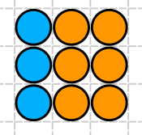
- There are 9 circles in this set. What part
of the set is made up of the blue circles?

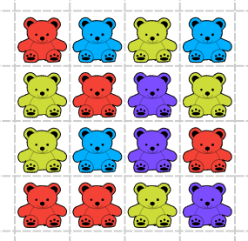
- How many bears are in the whole group?

- How many different parts can this group
be broken into?

- Color or shade in 3 parts of this whole group.
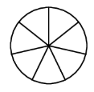

- Create your own group of at least 5 items. Label the whole group and each part.

